Note: Include this page only when adding / amending / deleting a document. If using this document as a record, this Revision History page can be omitted.

REVISION HISTORY

Revision no | Date | Description of Changes | Reason for Revision | Revised by | Approved by
00 | Mar. 14, 2014 | Initial document | To simplify BDM’s process | RDPlacido
01 | Apr. 8, 2016 | Added disclaimer when printing the document | For document control | RCGanal | RTMonzon
TM-BR-MG- 11 Rev02, 10302015

- Objective:

To support the company’s marketing and sales efforts by providing attractive and relevant website and collaterals that enhance the company’s image, provide useful information and, overall, entice prospective clients and partners to work with the company.

- Scope:

This procedure defines the actions & responsibilities of the Marketing Assistant in managing marketing collaterals and in maintaining the company website with the help of the IT Technical support.

This covers the following activities:
- Website Management
- Collateral Management

- Definition of Terms:

Marketing Collateral | A collection of media used to support the company’s marketing and sales operations. It includes brochures, data sheets, white papers, fliers, sales kits, catalogues, posters, folders, envelopes, letters, ecards, gift tags, invitations, etc.

- Procedure Details:

RESPONSIBLE | ACTIVITY | INTERFACE
Marketing Assistant | 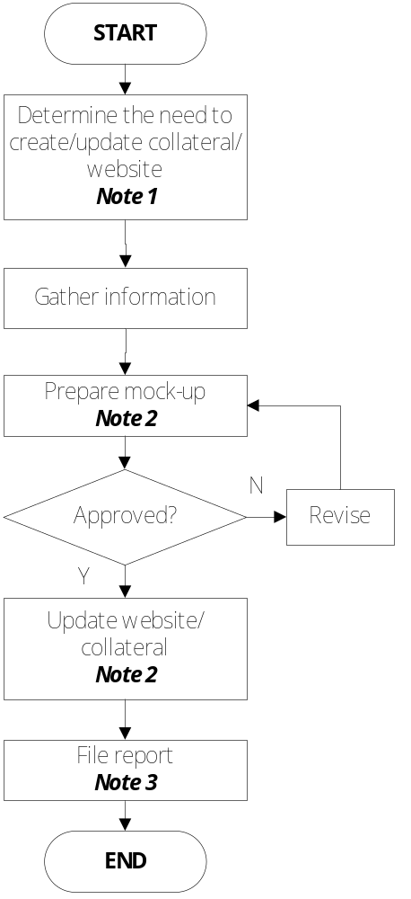 | ExeCom  Concerned Units  Collateral Obsolescence Review  Marketing Collateral Inventory Control  Website Management Report  Collateral Management Guideline  ExeCom  Website Management Report  Collateral Management Guideline

Notes:
- Developing new collaterals or updating existing website/collaterals may be required for a variety of reasons including:
  - New information about the company, products, services, etc.
  - New training schedule
  - Corporate News
  - Corporate events
  - Promotion / discounts
  - Request for new collaterals
  - Collateral Obsolescence review result
  - Marketing Collateral Inventory Control
  - Monthly Website Management Report

- Use designated supporting documents per activity:
  - Collateral Management
    - Marketing Collateral Management Guideline
    - Collateral Obsolescence Review Guideline
    - Collateral Obsolescence Review Template
    - Marketing Collateral Inventory Control
  - Website Management
    - Website Management Guideline
    - Website Management Report
For website mock-up, use the website dummy/test. Ask for Technical Support assistance.

- Use designated supporting documents per activity. Include this in the KPM Monitoring Report.

- References:

- Marketing Collateral Management Guideline
- Collateral Obsolescence Review Guideline
- Collateral Obsolescence Review Template
- Marketing Collateral Inventory Control
- Website Management Guideline
- Website Management Report

- Quality Records:

- Collateral Obsolescence Review Result
- Marketing Collateral Inventory Control
- Website Management Report

